LAB5:LINEAR REGRESSION

INTRODUCTION:-

Linear Regression is the most basic type of regression and commonly used in predictive analysis.
The overall idea of regression is to examine 2 things:-

1.Does a set of predictor variables to do a good job in predicting an outcome variable.
2.The regression equation that shows how the set of predictor variables can be used to predict volume?
The simplest form of equation with one dependent and one-independent variable is defined by:-
y=c+b*x
where
y – estimated dependent score
c-constant
b-regression
x-independent variable

LINEAR REGRESSION LEARNING-MODEL:-

The representation is a linear equation that combines a specific set of input values (x) the solution to which is the predicted output for that set of input values (y). As such, both the input values (x) and the output value are numeric.
The linear equation assigns one scale factor to each input value or column, called a coefficient and represented by the capital Greek letter Beta (B). One additional coefficient is also added, giving the line an additional degree of freedom (e.g. moving up and down on a two-dimensional plot) and is often called the intercept or the bias coefficient.
For example, in a simple regression problem (a single x and a single y), the form of the model would be:
y = B0 + B1*x
In higher dimensions when we have more than one input (x), the line is called a plane or a hyper-plane. The representation therefore is the form of the equation and the specific values used for the coefficients (e.g. B0 and B1 in the above example).
It is common to talk about the complexity of a regression model like linear regression. This refers to the number of coefficients used in the model.
When a coefficient becomes zero, it effectively removes the influence of the input variable on the model and therefore from the prediction made from the model (0 * x = 0). This becomes relevant if you look at regularization methods that change the learning algorithm to reduce the complexity of regression models by putting pressure on the absolute size of the coefficients, driving some to zero.
Now that we understand the representation used for a linear regression model, let’s review some ways that we can learn this representation from data.

OUTPUT IS:-

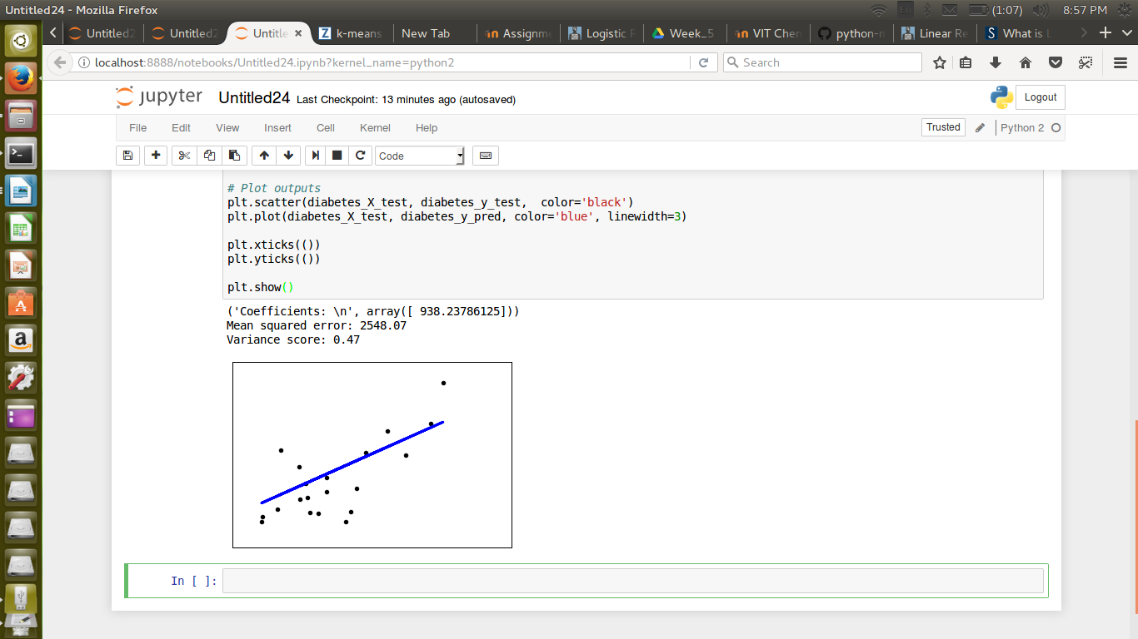
ipynb file imported

